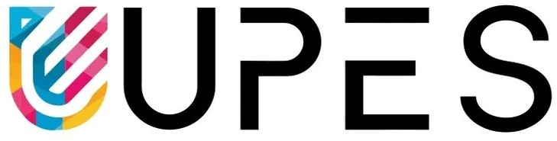

University of Petroleum &

Energy Studies

# SCHOOL OF COMPUTER SCIENCE

**Name**: Nancy Gumanta **Course**: BTech CSE **SAP ID**: 500121761

**BATCH**: 2

**PRESENTED TO**: Dr. Syed Sajid Hussain

**Semester**: 3

# Experiment 14: To understand the concepts of function and procedure in PL/SQL.

**Objective:** Students will be able to implement the Pl/SQL programs using function and procedure.

* **Implement the above experiments of PL/SQL using functions and procedures.**
  1. **Write a PL/SQL code to accept the value of A, B & C display which is greater.**

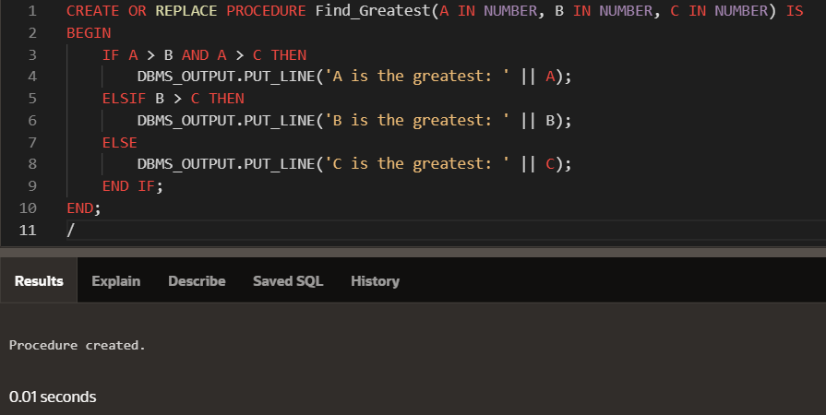INPUT:

OUTPUT:

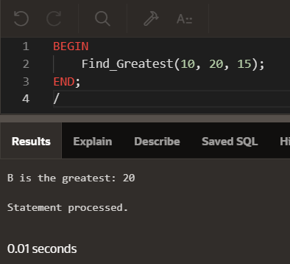

* 1. **Using PL/SQL Statements create a simple loop that display message “Welcome to PL/SQL Programming” 20 times.**

INPUT:

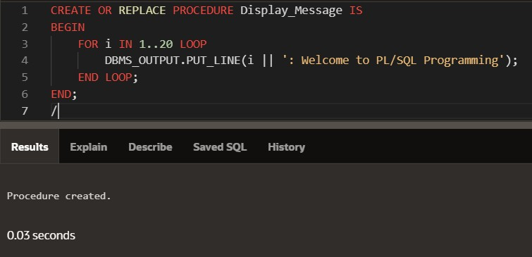

OUTPUT:

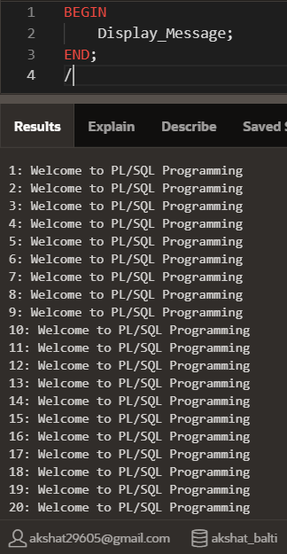

* 1. **Write a PL/SQL code block to find the factorial of a number. INPUT:**

Using Function:

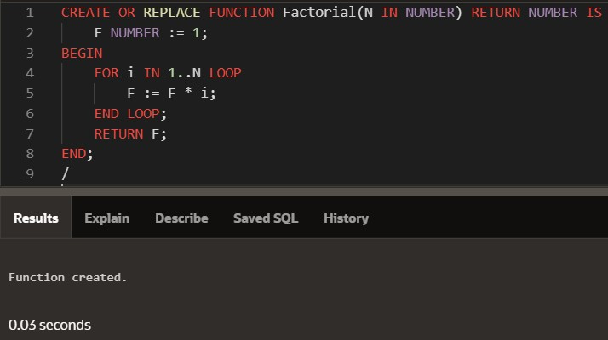

Using Procedure:

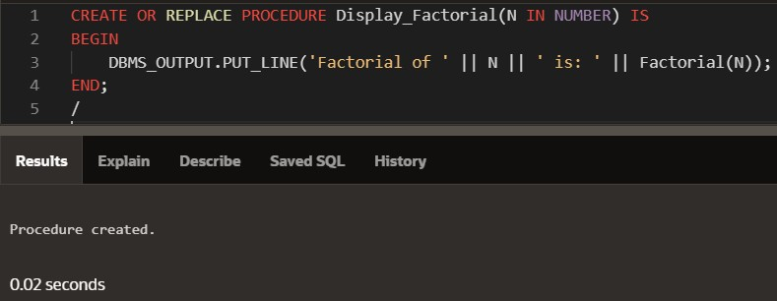

OUTPUT:

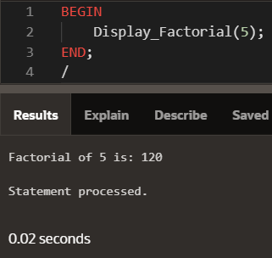

* 1. **Write a PL/SQL program to generate Fibonacci series. INPUT:**

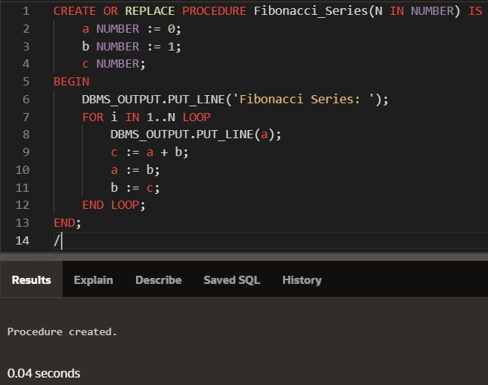

OUTPUT:

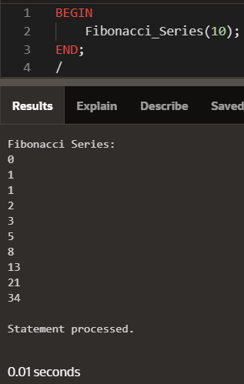

* 1. **Write a PL/SQL code to fund the sum of first N numbers INPUT:**

Using Function:

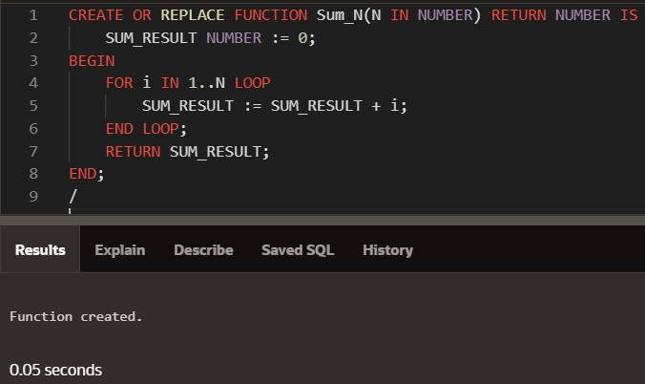

Using Procedure:

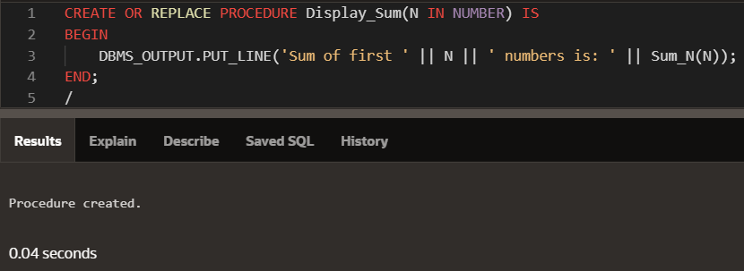

OUTPUT:

